

**KGiSL INSTITUTE OF TECHNOLOGY**

(Approved By AICTE, New Delhi, Affiliate to Anna University

Recognized by UGC, Accredited by NBA(IT)

265, KGISL Campus, Thudiyalur Road, Saravanampatti, Coimbatore-641035**.)**

**DEPARTMENT OF**

**ARTIFICIAL INTELLIGENCE AND DATA SCIENCE**

**NAAN MUDHALVAN - INTERNET OF THINGS**

**SMART PARKING**

**NAME:** Keerthana R

**REG NO:** 711721243046

**NM ID:** au711721243046

**TEAM MENTOR:** Mr**.** Mohankumar M

**TEAM EVALUATOR:** Ms. Akilandeeshwari M

**Smart Parking Project Definition and Design Thinking Document**

**Problem Statement**

Our challenge is to develop a smart parking solution using IoT technology. We aim to monitor real-time parking space occupancy, offer dynamic parking guidance to users, and seamlessly integrate these features into a mobile app. The ultimate goal is to enhance the efficiency and convenience of public parking services, alleviating the common difficulties of finding available parking spaces in urban areas.

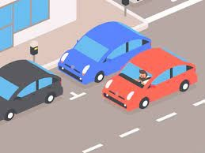

**Building Solution**

To transform the design and concept into an innovative smart parking solution, we'll follow a series of well-defined steps. This plan details how we'll put the design created in the previous phase into action.

**Step 1:** IoT Sensor System Implementation

*Objective:* To accurately monitor parking space occupancy in real time.

Sensor Selection: Choose the appropriate IoT sensors based on cost, accuracy, and compatibility. Considering factors like weather resistance, power efficiency, and ease of maintenance will be essential.

Deployment Strategy: Determine the optimal sensor placement within the parking lot. Perform a site survey to identify high-traffic areas and potential blind spots.

Data Transmission: Establish a reliable data transmission method, such as Wi-Fi, Bluetooth, or LoRa, to transmit sensor data to a central data aggregator step.

**Step 2:** Mobile App Development

*Objective:* To provide users with real-time parking information and guidance.

Mobile App Interface: Design and develop an intuitive mobile app interface that displays real-time parking availability. Ensure the app provides directions to open parking spaces and alternative routes.

User Engagement: Incorporate mechanisms for user feedback, such as ratings and comments, to continuously improve the app's usability.

Data Visualization: Create visible representations of parking availability on a map, making it easy for users to identify vacant spaces.

**Step 3:** Effective Parking Management

*Objective:* Maximize parking utilization, reduce congestion, and minimize waiting times.

Algorithm Implementation: Implement algorithms for data processing and analysis to ensure the accuracy of parking space availability information.

Integration with Raspberry Pi: Utilize Raspberry Pi or similar solutions for collecting data from IoT sensors and processing it in real-time.

Communication Protocol: Develop a stable and efficient communication protocol that seamlessly connects the IoT sensor system with the mobile app. This protocol should support real-time updates.

Real-Time Updates: Ensure that the mobile app receives real-time updates on parking space availability and immediately notifies users.

**Step 4:** Testing and Quality Assurance

*Objective:* Ensure the system works flawlessly and meets the project objectives.

Sensor Testing: Conduct thorough testing of IoT sensors to validate their accuracy and reliability.

Mobile App Testing: Test the mobile app across various devices and platforms to ensure a consistent and user-friendly experience.

System Integration Testing: Perform tests to verify that the IoT sensor system and the mobile app communicate effectively.

**Step 5:** Pilot Deployment

*Objective:* Deploy the smart parking solution in a controlled environment for initial testing and feedback gathering.

Select a Pilot Location: Choose a small parking area or facility to serve as the initial deployment site.

User Feedback Collection: Collect feedback from users and parking attendants to make necessary improvements and adjustments.

**Step 6:** Full-Scale Deployment

*Objective:* Deploy the smart parking solution in a real-world setting.

Select Deployment Locations: Identify urban areas with high parking demand and deploy the system in multiple locations.

User Training: Provide training and support to users and parking attendants.

Monitoring and Maintenance: Establish a system for continuous monitoring and maintenance to ensure the solution's long-term functionality.

**Step 7:** Continuous Improvement

*Objective:* Continuously refine and enhance the system based on user feedback and emerging technologies.

Feedback Loop: Maintain a feedback loop with users to address issues, gather suggestions, and make iterative improvements.

Technology Updates: Stay up-to-date with advancements in IoT technology, mobile app development, and data processing to keep the system current and efficient.

**Flowchart:**

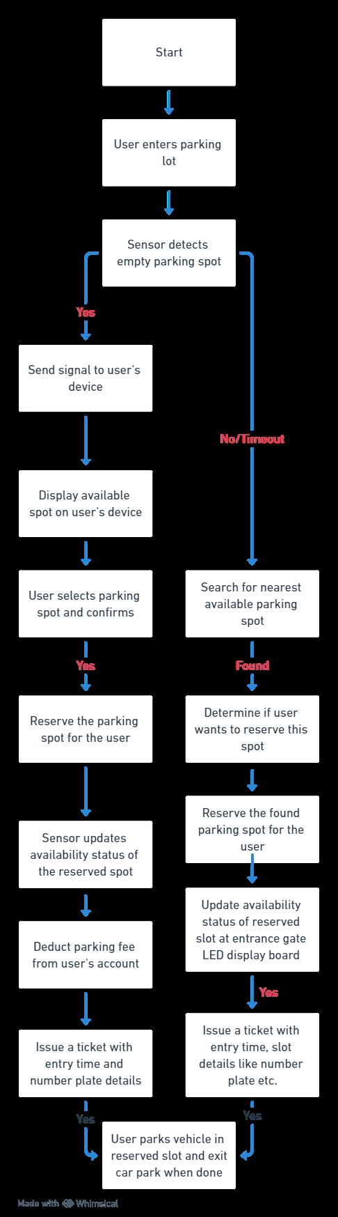

**Benefits of Smart parking:**

* Efficiency: Smart parking systems save time and fuel by quickly directing drivers to available parking spaces.
* Less Congestion: They reduce traffic jams by minimizing the time spent searching for parking spots.
* Data Insights: These systems collect data to help cities make informed decisions about traffic management.
* Improved Safety: Features like cameras and emergency buttons enhance safety in parking areas.
* Convenience: Real-time updates and remote payments make parking easier for drivers.

